September 07, 2017

D E C L A R A T I O N
of the
Chisme.Dailyurbano.com

- POSTS

when you will login as admin on the dashboard you will get the menu named posts.

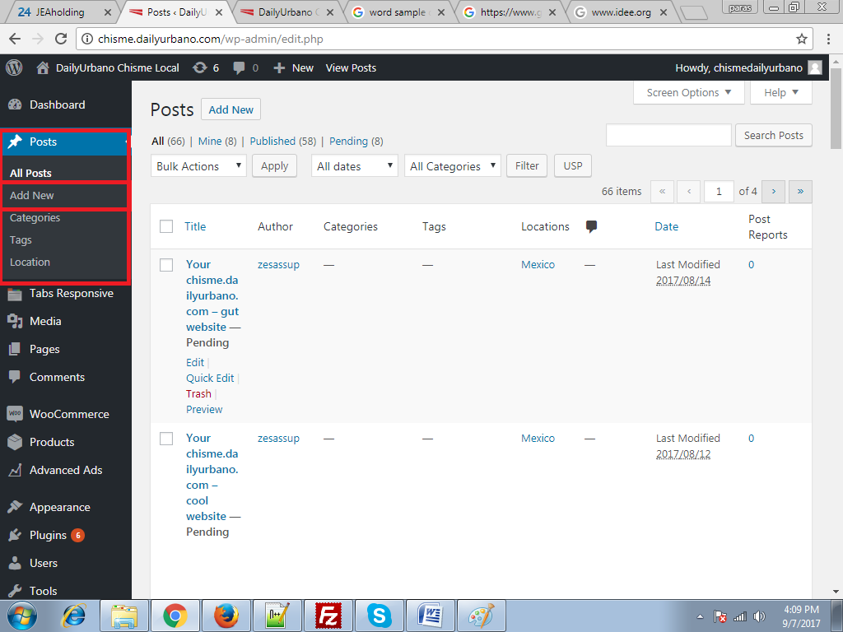

After click on add post you will get that window

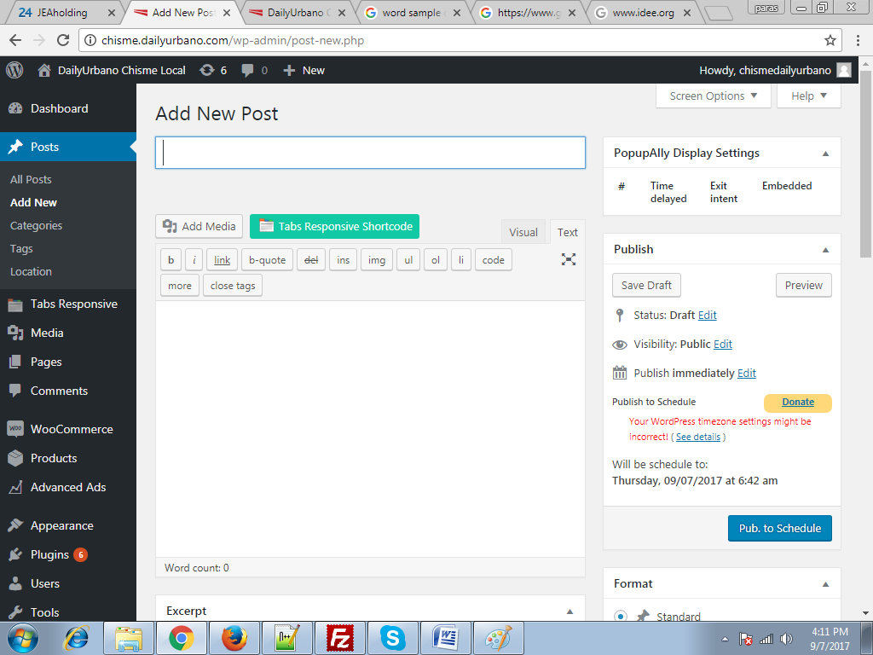

After that you will fill the information and post scheduling is same as dailyurbano.com

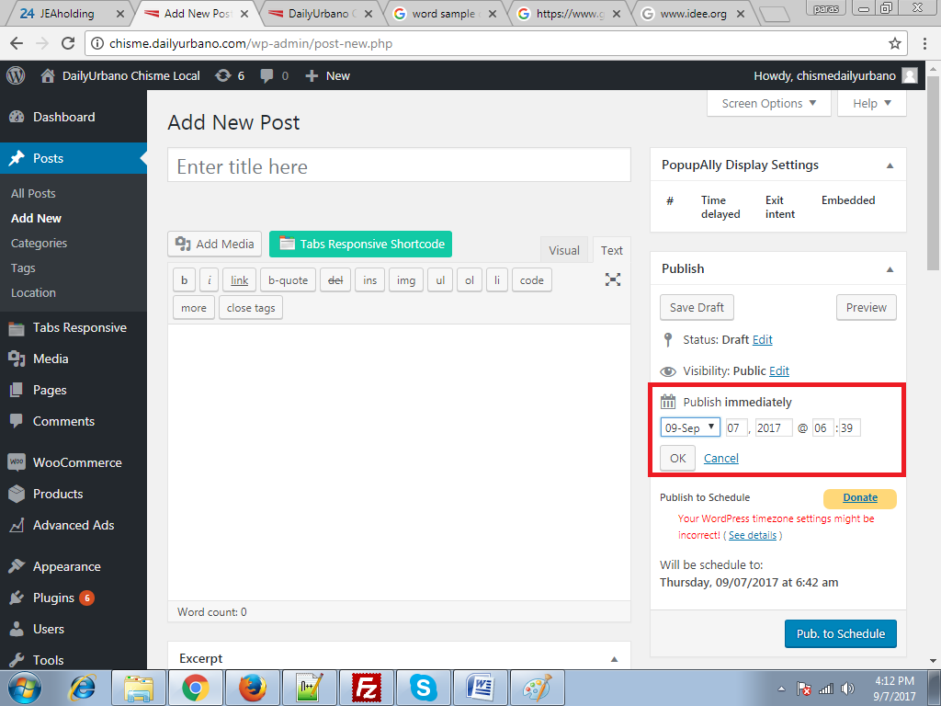

When you scroll down on the same page at the right side you will see category
And locations to select location or categories you can select location.

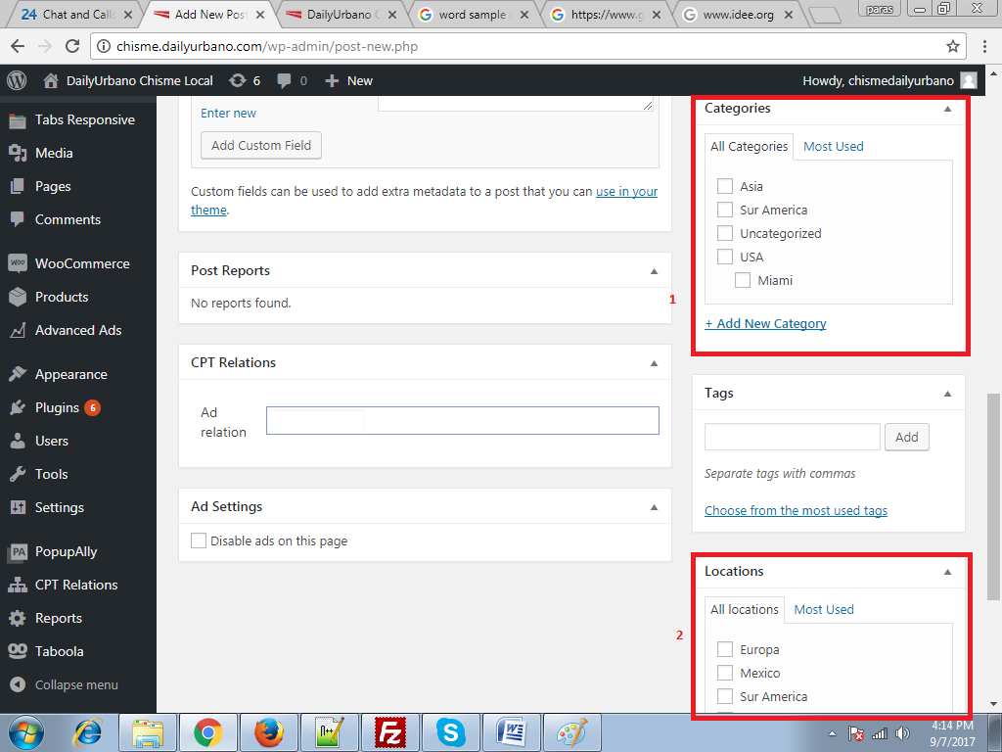

TO REALATE ADS WITH POST:

On the add post page you can see the option

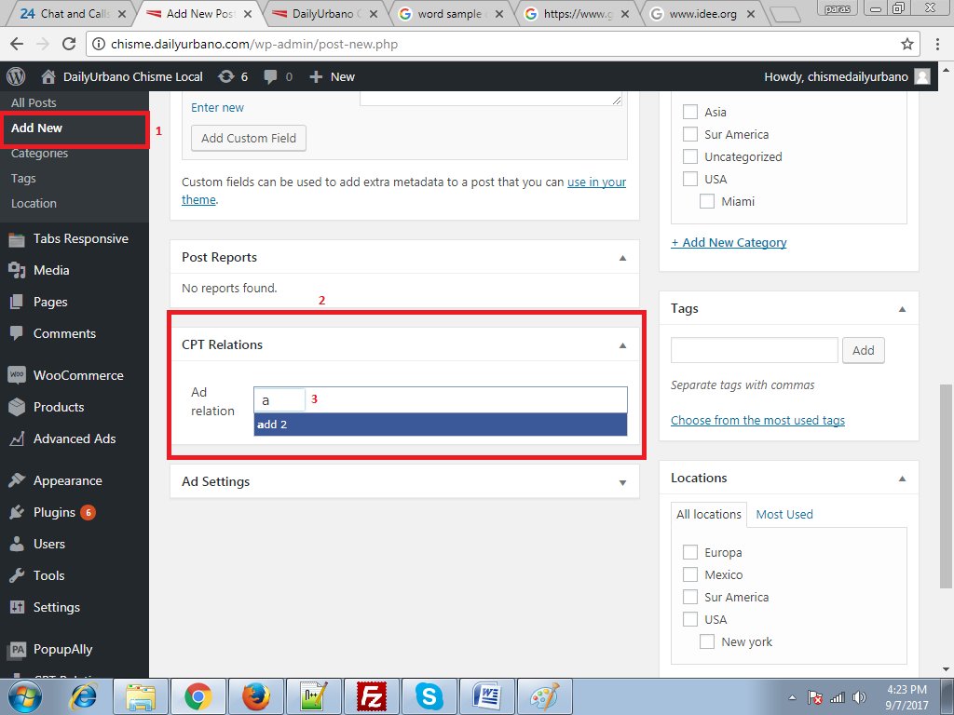

When you search the add this will show add you have to select the add and then save the post it will start showing that add under that post automatically

TO ADD ADVERTISEMENT:

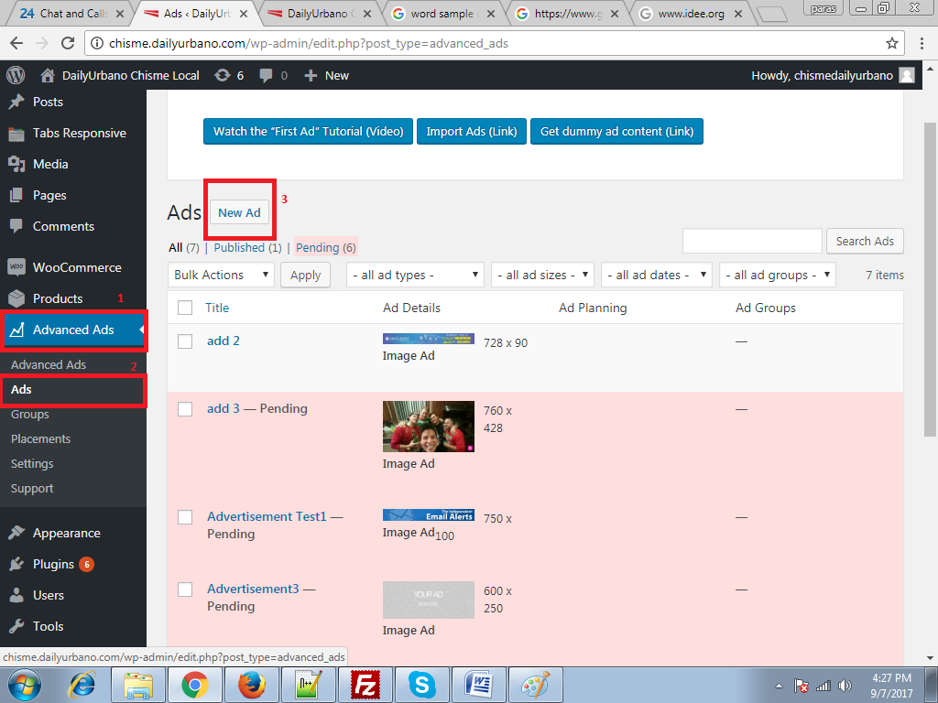

To add new add Click on no. 1 then click on no. 2 . then click on no. 3

Then you can add new add and that add will show in add post page also.

